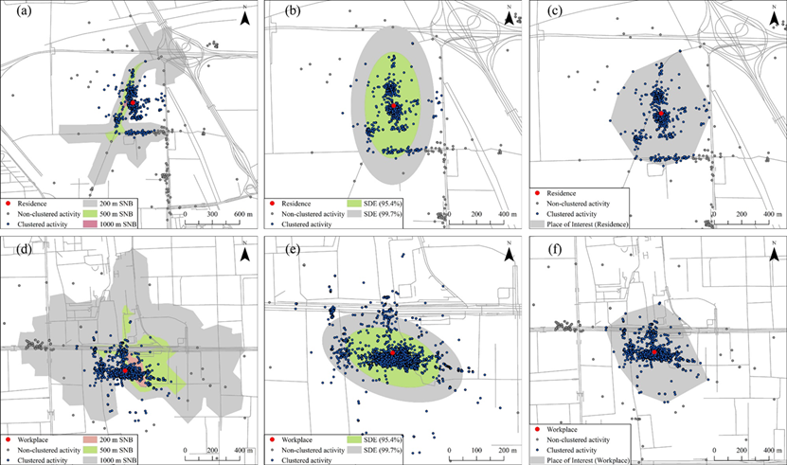
Figure S1. Results of different representation methods of localized activity spaces (localized SNB, SDE, MCP from left to right) corresponding to two typical urban structure: a sparse street network (a), (b), (c) and a dense street network (d), (e), (f).

Table S1. A summary evaluation of representativeness of the localized activity spaces.
Geographical Representation | Ratio of Clustered Activity Locations | Ratio of Non-Clustered Activity Locations | Area (km²) | Geometry Restrictions
200 m Street network buffer | 11.3% | 0.0% | 0.02 | Street network
500 m Street network buffer | 36.7% | 5.3% | 0.15 | Street network
1000 m Street network buffer | 86.8% | 21.0% | 1.17 | Street network
Standard deviation ellipse (95%) | 95.4% | 0.0% | 0.05 | Data & Ellipse
Standard deviation ellipse (99%) | 99.7% | 0.2% | 0.42 | Data & Ellipse
Local minimum convex polygon | 100.0% | 0.0% | 0.40 | Data

Table S2. Spatial extent, average stay duration and frequency of stay activities around the anchor places and along the commuting routes (n = 107).
 | RS |  | WS |  | OMS |  | DPA ª
 | Mean (SD) | Range | Mean(SD) | Range | Mean(SD) | Range | Mean(SD) | Range
Area (km²) | 0.5 (0.9) | 0.1–3.6 | 0.3 (0.2) | 0.1–1.1 | 0.2 (0.3) | 0.1–1.4 | 0.2 (0.3) | 0.1–1.2
Perimeter (km) | 2.7 (1.9) | 0.4–7.5 | 2.1(0.9) | 0.6–4.6 | 1.9 (1.1) | 0.6–4.4 | 4.9 (6.1) | 0.3–9.9
Duration ^{b} (min/day) | 55.4 (77.3) | 20.7–419.3 | 38.7 (52.9) | 0.0–263.6 | 15.8 (26.9) | 0.0–124.1 | 17.0 (24.8) | 0.6–122.6
Activities ^{c} (times/day) | 1.8 (1.3) | 0.2–6.2 | 1.3 (0.7) | 0.2–3.7 | 0.6 (0.6) | 0.1–2.6 | 1.4 (2.1) | -
Note: ª Food exposure of DPA were defined as the sum of food outlets count along the commuting routes between activity spaces, accounting for transport modes. ^{b} Calculated as the average time people spent around the residences, workplaces, other anchor places and along the non-motorised commuting paths per day. The calculation was strictly based on the GPS trajectories, without estimating of people’s stay duration indoors that were not recorded. ^{c} Calculated as the count of stay activities around the anchor places per day. Abbreviations: RS-residential space, WS-workspace, OMS-other major space, DPA-non-motorized commuting path area.

