Supplementary material: Genomic Characterization of the Genus Nairovirus (Family Bunyaviridae)
Jens H. Kuhn ¹, Michael R. Wiley ², Sergio E. Rodriguez ³, Yīmíng Bào ⁴, Karla Prieto ²,
Amelia P. A. Travassos da Rosa ³, Hilda Guzman ³, Nazir Savji ⁵, Jason T. Ladner ²,
Robert B. Tesh ³, Jiro Wada ¹, Peter B. Jahrling ¹, Dennis A. Bente ³ and Gustavo Palacios ^{2,}*

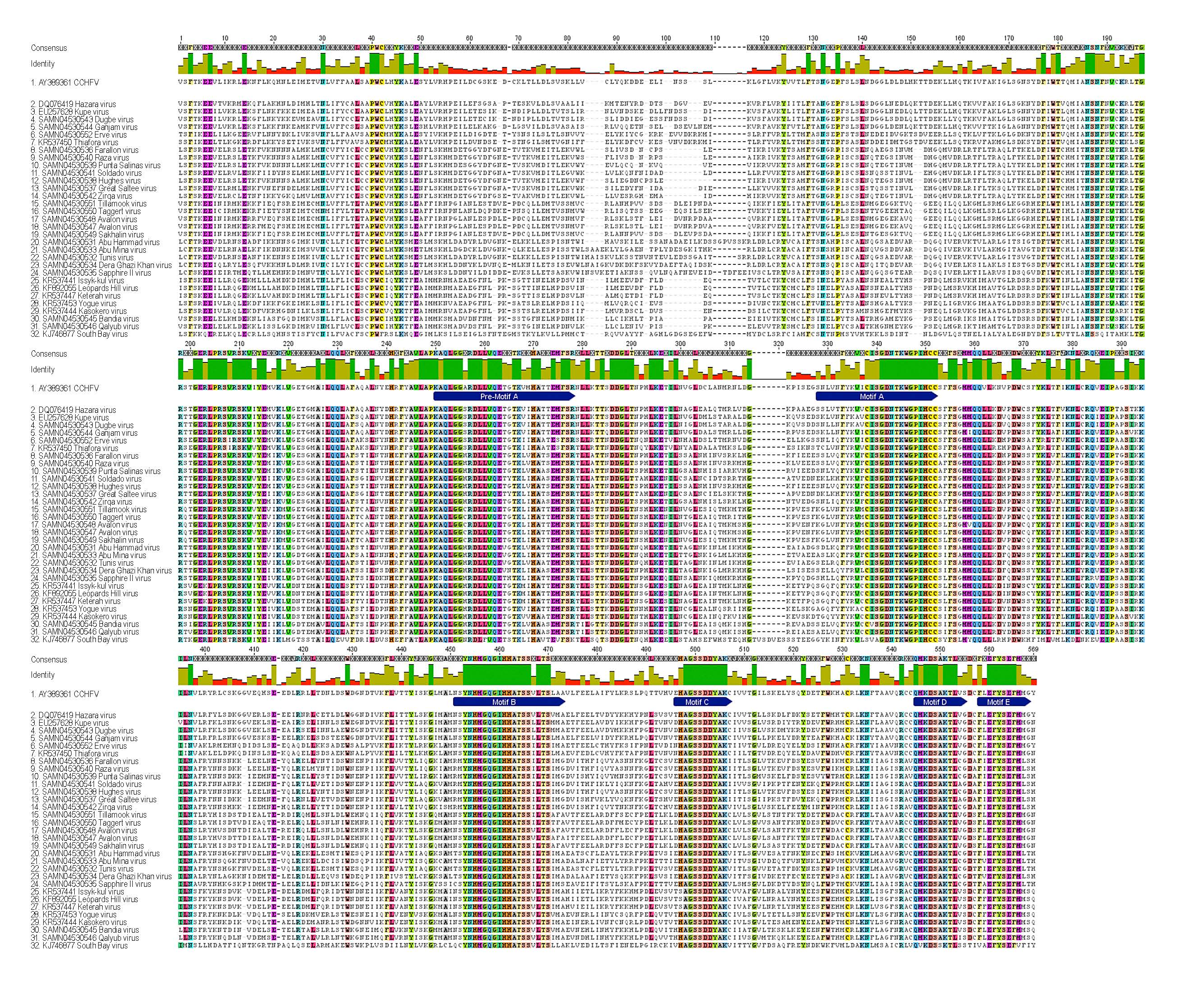
Figure S1: S7-1 Domain A
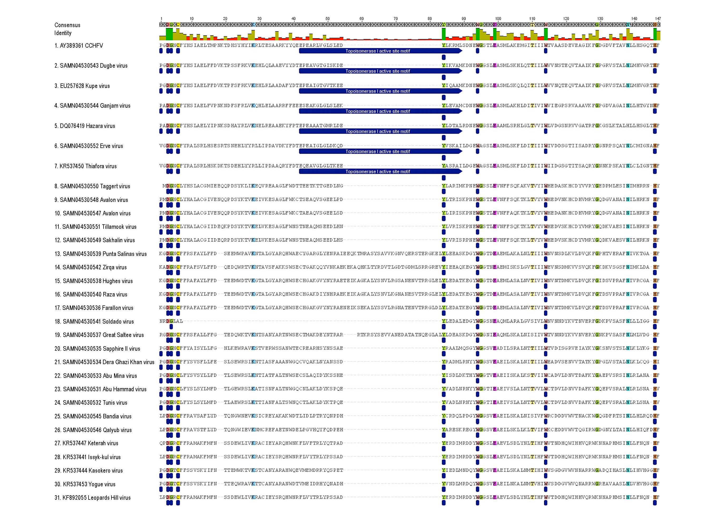
Figure S2: S7-2 OTU
Figure S3: S7-3 Domain B
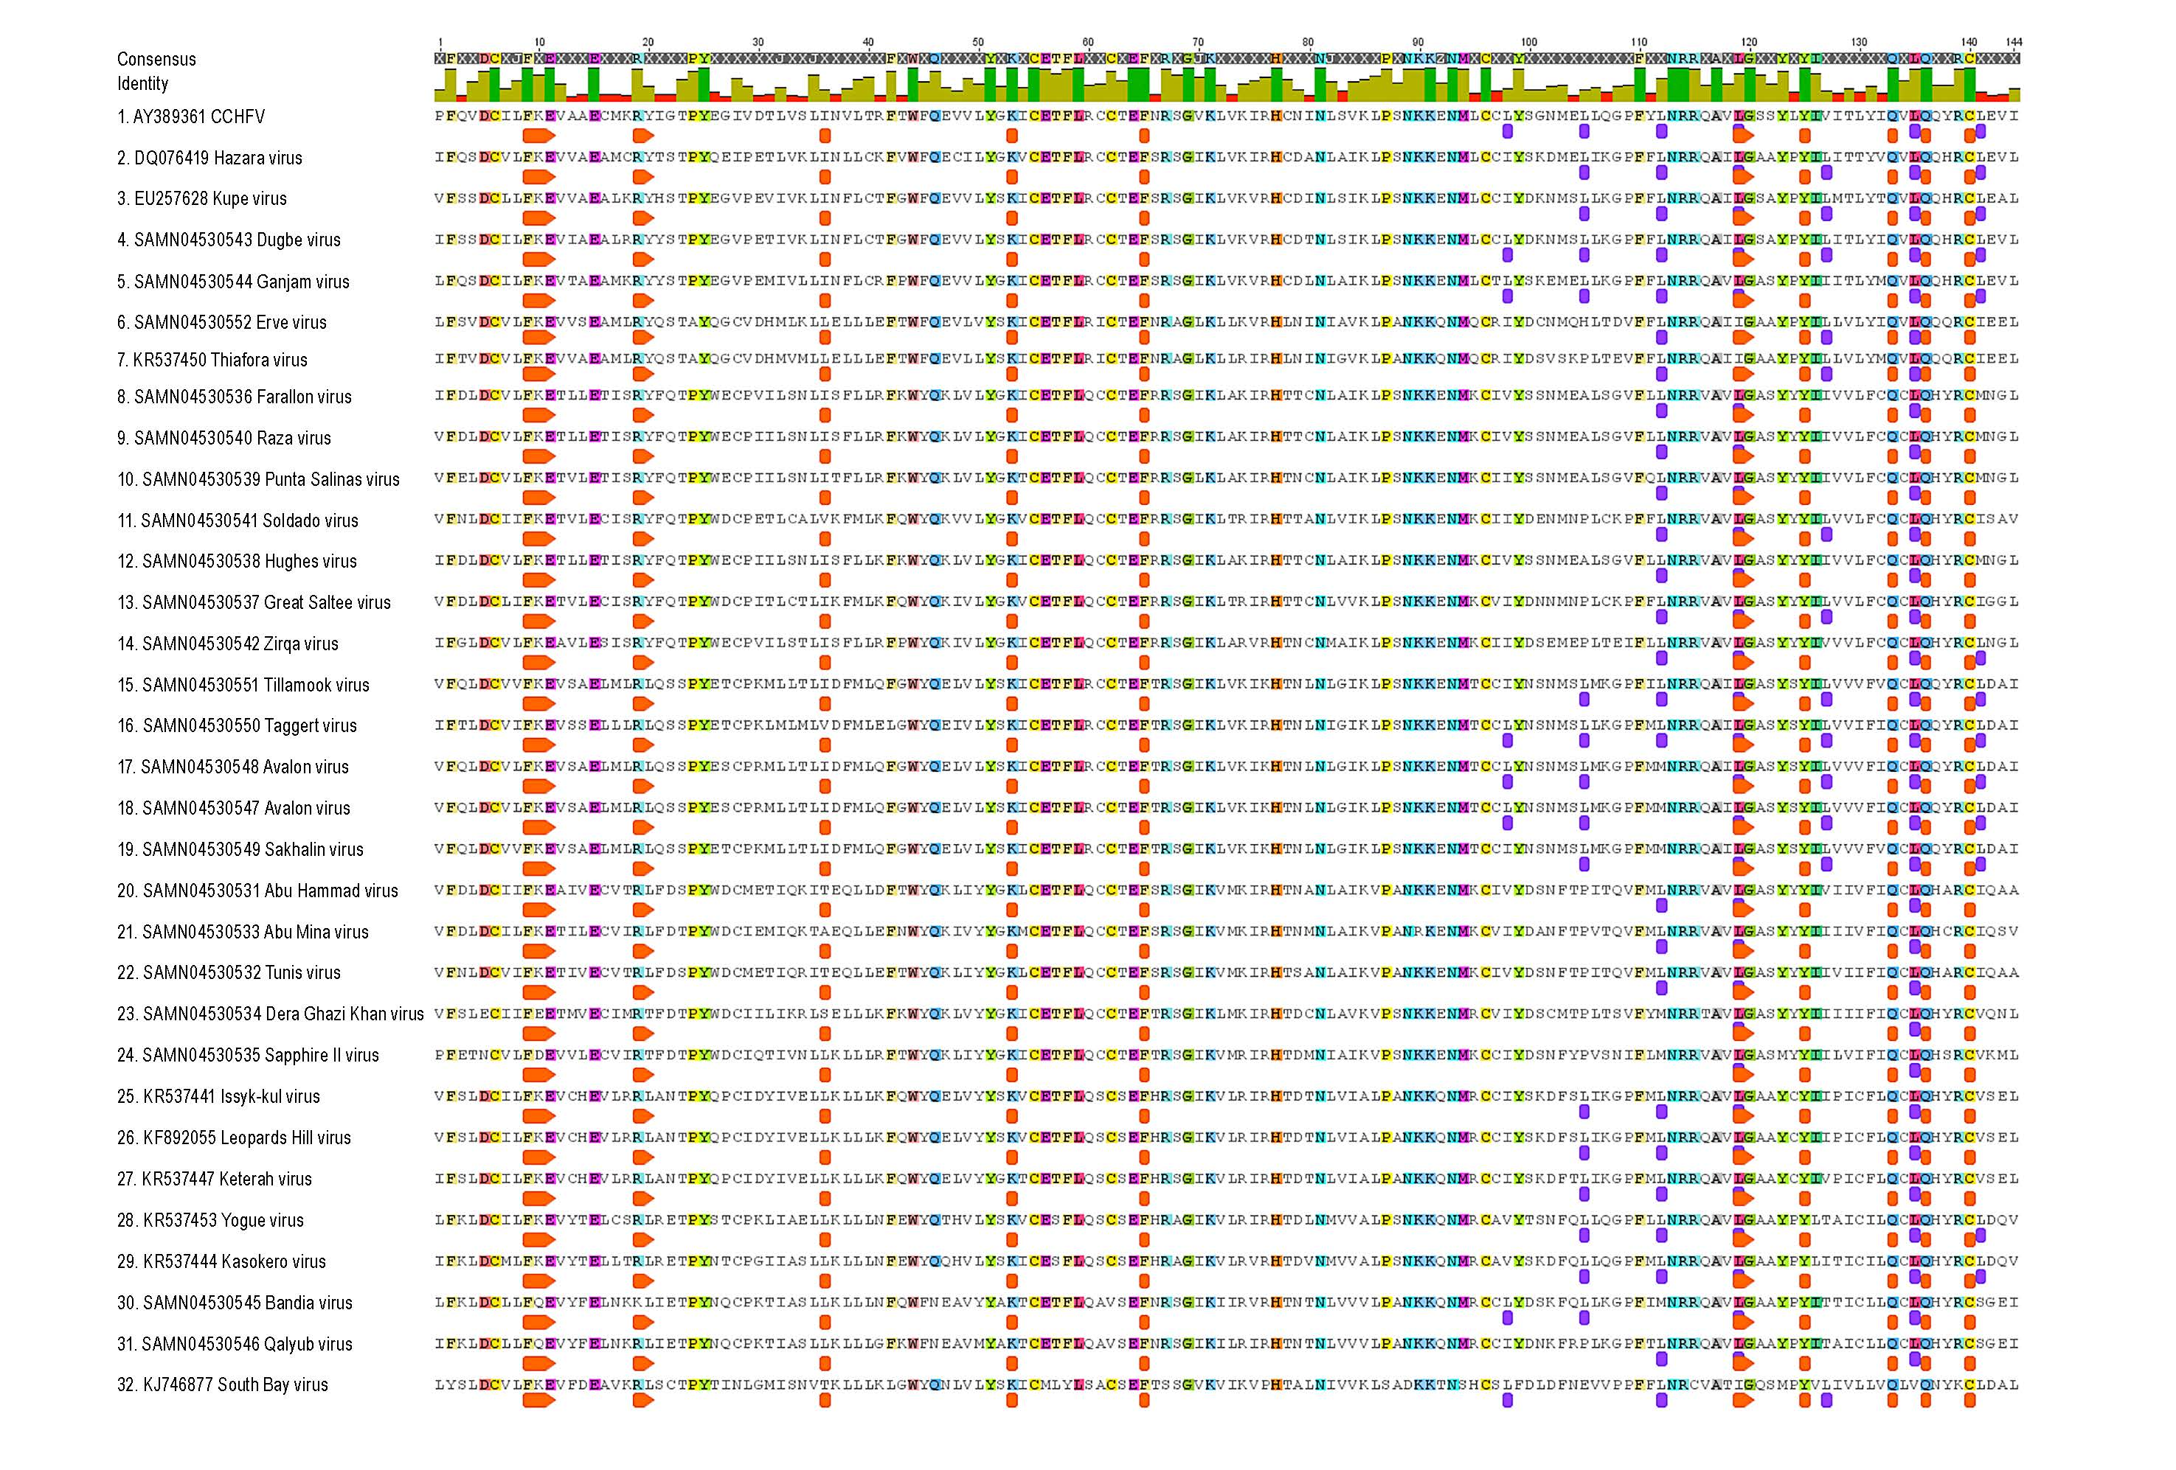

Figure S4: S7-4 Domain C
Figure S5: S7-5 Domain D

Table S1. Nairovirus and nairo-like viruses and their deduced relationships prior to this study (based in part on [1‒23]). a Genomic segments are representative complete or coding-complete sequences. NK, not known; NR, not recorded; TBD, to be determined.
Nairovirus Species and Virus Members (Abbreviations) | Virus Vector(s) | Virus Vertebrate Host(s) | Human infections | Genomic Segment Accession Numbers (RefSeq/GenBank)ª
Species Crimean-Congo hemorrhagic fever nairovirus
Crimean-Congo hemorrhagic fever virus (CCHFV) | Biting midges (Culicoides sp.)  Ticks (Alveonasus lahorensis, Argas persicus, Amblyomma spp., Dermacentor dagestanicus, D. marginatus, Haemaphysalis punctata, Hyalomma anatolicum, H. asiaticum, H. detritum, H. excavatum, H. impeltatum, H. impressum, H. lusitanicum, H. marginatum, H. nitidum, H. punctatum, H. truncatum, Ixodes ricinus, Rhipicephalus annulatus, R. bursa, R. decoloratus, R. geigyi, R. microplus, R. pulchellus, R. pumilio, R. rossicus, R. sangineus, R. turanicus) | Birds, camelids, cattle, eulipotyphla, humans, lagomorphs, rodents, sheep | Yes: Crimean-Congo hemorrhagic fever (frequently lethal) | S: NC_005302.1  M: NC_005300.2  L: NC_005301.3
Hazara virus (HAZV) | Ticks (Ixodes redikorzevi) | Royle’s mountain voles (Alticola roylei)? | NR | S: KP406725.1  M: KP406724.1  L: KP406723.1
Tofla virus (TFLV) | Ticks (Heamaphysalis flava and Heamaphysalis formsensis) | Rodents? | NR | S: LC008510.1  M: LC008511.1  L: LC008512.1

Species Dera Ghazi Khan nairovirus
Abu Hammad virus (AHV) | Ticks (Argas hermanni) | Pigeons? | NR | This study and [23]:  S. KU343144.1  M: KU343143.1  L: KU343142.1
Abu Mina virus (AMV) | Ticks (Argas streptopelia) | European turtle doves (Streptopelia turtur)? | NR | This study
Dera Ghazi Khan virus (DGKV) | Ticks (Hyalomma dromedarii) | Camelids? | NR | This study and [23]:  S: KU343153.1  M: KU343152.1  L: KU343151.1
Kao Shuan virus (KSV) | Ticks (Argas robertsi) | Night herons (Nycticorax nycticorax)? | NR | TBD
Pathum Thani virus (PTHV) | Ticks (Argas robertsi) | Open-billed storks (Anastomus ascitans)? | NR | TBD
Pretoria virus (PREV) | Ticks (Argas africolumbae) | Cape rock pigeons (Columba guinea phaeonata)?) | NR | TBD
Sapphire II virus (SAPV) | Ticks (Argas cooley) | Seabirds? | NR | This study and [23]:  S: KU343165.1  M: KU343164.1  L: KU343163.1
Species Dugbe nairovirus
Dugbe virus (DUGV) | Biting midges (Culicoides sp.)  Ticks (Amblyomma variegatum, A. lepidum, Hyalomma truncatum, H. rufipes, Ixodes sp., Rhipicephalus decoloratus,) | Cattle, giant pouched rats (Cricetomys gambianus) | Yes (rare): diarrhea, fever, headache, maculopapular rash, nausea, vomiting (non-lethal) | S: NC_004157.1  M: NC_004158.1  L: NC_004159.1
Ganjam virus (GANV) | Mosquitoes (Culex vishnui)  Ticks (Haemaphysalis intermedia, H. wellingtoni, Rhipicephalus haemaphysaloides) | Domestic sheep and goats | Yes (rare): fever (non-lethal) | Yadav et al. and this study:  S: AF504294.1  M: EU697950.1  L: EU697949.1
Kupe virus (KUPEV) | Ticks (Amblyomma gemma, Rhipicephalus pulchellus) | Livestock? | NR | S: EU257626.1  M: EU257627.1  L: EU257628.1
Nairobi sheep disease virus (NSDV) | Ticks (Amblyomma variegatum, Haemaphysalis intermedia, Rhipicephalus appendiculatis, R. pulchellus, R. simus) | Domestic sheep and goats | Yes (rare): abdominal pain, fever, headache, myalgia (non-lethal) | S: KM464724.1  M: KM464725.1  L: KM464726.1
Species Hughes nairovirus
Caspiy virus (CASV) | Ticks (Carios capensis) | Common terns (Sterna hirundo), European herring gulls (Larus argentatus) | NR | Not yet deposited
Elliðaey virus ELL 81-3b | Ticks (Ixodes uriae) | Atlantic puffins (Fratercula arctica)? | NR | TBD
Farallon virus (FARV) | Ticks (Carios denmarki) | Western gulls (Larus occidentalis)? | NR | This study and [23]:  S: KU343156.1  M: KU343155.1  L: KU343154.1
Fraser Point virus (FPV) | NK | NK | NR | TBD
Foula virus F 80-1 | Ticks (Ixodes uriae) | Common murees (Uria aalge)? | NR | TBD
Great Saltee virus (GRSV) | Ticks (Carios maritimus, Ixodes uriae) | Black-legged kittiwakes (Rissa tridactyla), European shags (Phalacrocorax aristotelis), Razorbills (Alca torda)? | NR | This study
Grímsey virus GRIMS82-1b | Ticks (Ixodes uriae) | Atlantic puffins (Fratercula arctica)? | NR | TBD
Hughes virus (HUGV) | Ticks (Carios denmarki) | Brown noddies (Anous stolidus), sooty terns (Sterna fuscata)? | NR | This study
Inner Farne Island virus IF 80-3, IF80-4 | Ticks (Ixodes uriae) | Common murees (Uria aalge)? | NR | TBD
Island of May virus IM81 | Ticks (Ixodes uriae) | Common murees (Uria aalge)? | NR | TBD
Mykines virus M82-2 | Ticks (Ixodes uriae) | Atlantic puffins (Fratercula arctica)? | NR | TBD
Puffin Island virus (PIV) | Ticks (Carios maritimus) | Seabirds? | NR | TBD
Punta Salinas virus (PSV) | Ticks (Argas arboreus, Carios amblus) | Guanay cormorants (Phalacrocorax bougainvillii), Peruvian boobies (Sula variegata)? | NR | This study and [23]:  S: KU343159.1  M: KU343158.1  L: KU343157.1
Raza virus (RAZAV) | Ticks (Carios denmarki) | Seabirds? | NR | This study
Soldado virus (SOLV) | Ticks (Amblyomma loculosum, Carios capensis, C. denmarki) | Brown noddies (Anous stolidus), Cape cormorants (Phalacrocorax capensis), great cormorants (Phalacrocorax carbo), grey-headed gulls (Chroicocephalus cirrocephalus), long-tailed cormorants (Phalacrocorax africanus), masked boobies (Sula dactylatra), sooty terns (Sterna fuscata)? | NR | This study
Zirqa virus (ZIRV) | Ticks (Carios muesebecki) | Ospreys (Pandion haliaetus), Socotra cormorants (Phalacrocorax nigrogularis)? | NR | This study and [23]:  S: KU343171.1  M: KU343170.1  L: KU343169.1
Species Qalyub nairovirus
Bakel virus (BAKV) | Ticks (Ornithodoros sonrai) | NK | NR | TBD
Bandia virus (BDAV) | Ticks (Ornithodoros sonrai) | Multimammate rats  (Mastomys sp.) | NR | This study and [23]:  S: KU343150.1  M: KU343149.1  L: KU343148.1
Chim virus (CHIMV) | Ticks (Hyalomma asiaticum, Ornithodoros papillipes, O. tartakovskii, Rhipicephalus turanicus) | Great gerbils (Rhombomys opimus)? | NR | Not yet deposited
Geran virus (GERV/GRNV) | Ticks (Ornithodoros verrucosus) | Libyan jirds (Meriones lybicus)? | NR | Not yet deposited
Omo virus (OMOV) | NK | Reddish-white mastomys (Mastomys erythroleucus) | NR | TBD
Qalyub virus (QYBV) | Ticks (Carios erraticus) | African arvicanthis (Arvicanthis niloticus), camelids, cattle, pigs, dogs, donkeys | NR | This study and [23]:  S: KU343162.1  M: KU343161.1  L: KU343160.1
Species Sakhalin nairovirus
Avalon virus (AVAV) = Paramushir virus (PRMV)? | Ticks (Ixodes signatus, I. uriae) | Atlantic puffins (Fratercula arctica), European herring gulls (Larus argentatus), Leach's storm petrels (Oceanodroma leucorhoa)? | NR | This study and [23]:  S: KU343147.1  M: KU343146.1  L: KU343145.1
Clo Mor virus (C[L]MV) | Ticks (Ixodes uriae) | Common murees (Uria aalge)? | NR | This study and [23]:  S: KU343141.1  M: KU343140.1  L: KU343139.1
Finch Creek virus (FINCV) | Ticks (Ixodes uriae) | Penguins? | NR | TBD
Kachemak Bay virus (KBV) | Ticks (Ixodes signatus) | Common murees (Uria aalge)? | NR | TBD
Sakhalin virus (SAKV) | Ticks (Ixodes putus, I. signatus, I. uriae) | Black-legged kittiwakes (Rissa tridactyla), common murees (Uria aalge), Northern fulmars (Fulmaris flacialis), red-necked phalaropes (Phalaropus lobatus), tufted puffins (Lunda cirrhata)? | NR | This study
Taggert virus (TAGB) | Ticks (Ixodes uriae) | Macaroni penguins (Eudyptes chrysolophus)? | NR | This study and [23]:  S: KU343168.1  M: KU343167.1  L: KU343166.1
Tillamook virus (TILLV) | Ticks (Ixodes uriae) | Seabirds? | NR | This study
Species Thiafora nairovirus
Erve virus (ERVEV) | NK | Greater white-toothed shrews (Crocidura russula) | Possibly: thunderclap headaches (non-lethal)? | S: JF911699.1  M: JF911698.1  L: JF911697.1
Thiafora virus (TFAV) | NK | White-toothed shrews  (Crocidura sp.) | NR | Coding-complete:  S: KR537452.1  M: KR537451.1  L: KR537450.1
Putative species “Ahun nairovirus”
Ahun virus | NK | Common pipistrelles (Pipistrellus pipistrellus), whiskered myotis (Myotis mystacinus) | NR | TBD

Putative species “Issyk-kul nairovirus/Keterah nairovirus”
Garm virus | NK | Common redstarts (Phoenicurus phoenicurus) | NR | TBD
Gossas virus (GOSV) | NK | Free-tailed bats (Tadarida sp.) | NR | Coding-complete:  S: KR534876.1  M: KR534877.1  L: KR534878.1
Issyk-kul virus (ISKV) | Biting midges (Culicoides schultzei)  Horseflies (Tabanus agrestis)  Mosquitoes (Aedes caspius, Anopheles hyrcanus)  Ticks (Argas vespertilionis, A. pusillus, Ixodes vespertilionis) | Humans  Bats: noctules (Nyctalus noctula), lesser mouse-eared myotis (Myotis blythii), common serotines (Eptesicus serotinus), particolored bats (Vespertilio murinus), common pipistrelles (Pipistrellus pipistrellus), greater horseshoe bats (Rhinolophus ferrumequinum)  Birds: Spanish sparrows (Passer hispaniolensis), white wagtails (Motacilla alba), grey wagtails (Motacilla cinerea), common redstarts (Phoenicurus phoenicurus), house swallows (Hirundo rustica), wrynecks (Jynx torquilla), common kingfishers (Alcedo atthis) | Yes (rare): cough, fever, headache, nausea (non-lethal) | Complete:  S: KF892057.1  M: KF892056.1  L: KF892055.1
Keterah virus (KTRV) | Ticks (Argas pusillus) | Asiatic yellow house bats (Scotophilus kuhlii temminckii) | NR | S: KR537449.1  M: KR537448.1  L: KR537447.1
soft tick bunyavirus (STBV) | Ticks (Argas vespertilionis) | Bats? | NR | S: LC027467.1  M: LC027466.1  L: LC027465.1
Uzun-Agach virus (UZAV) | NK | Lesser mouse-eared myotis (Myotis blythii oxygnathus) | NR | TBD

Putative species “Kasokero nairovirus”
Leopards Hill virus (LPHV) | NK | Giant leaf-nosed bats (Hipposideros gigas) | NR | S: NC_025833.1  M: NC_025832.1  L: NC_025831.1
Kasokero virus (KAS[O]V) | NK | Egyptian rousettes (Rousettus aegyptiacus) | Yes (rare): mild to severe laboratory infections characterized by abdominal pain, diarrhea, fever, headache, and severe myalgia and arthralgia (nonlethal) | Coding-complete  S: KR537446.1  M: KR537445.1  L: KR537444.1
Yogue virus (YOGV) | NK | Egyptian rousettes (Rousettus aegyptiacus) | NR | Coding-complete:  S: KR537455.1  M: KR537454.1  L: KR537453.1
Putative species “Burana nairovirus”
Burana virus (BURV) | Ticks (Haemaphysalis concinna, H. punctata) | Domestic cows? | NR | Not yet deposited
Huángpí tick virus 1 (HTV-1) | Ticks (Haemaphysalis doenitzi) | NK | NR | S: KM817734.1  M: KM817706.1  L: KM817667.1
Tǎchéng tick virus 1 (TTV-1) | Ticks (Dermacentor marginatus) | NK | NR | S: KM817743.1  M: KM817717.1  L: KM817683.1
Tamdy virus (TDYV) | Ticks (Haemaphysalis anatolicum,  H. asiaticum, H. concinna, Hyalomma marginatum, Rhipicephalus turanicus) | Birds: white wagtails (Motacilla alba), European rollers (Coracias garrulus), hoopoes (Upupa epops), common starlings (Sturnus vulgaris), southern grey shrikes (Lanius meriodinalis)  Carnivores: steppe polecats (Mustela eversmanni)  Rodents: great gerbils (Rhombomys opimus)  Unspecified bats  Domestic sheep? | Yes (rare): arthralgia, fever, myalgia (nonlethal) | Not yet deposited
Wēnzhōu tick virus (WTV) | Ticks (Haemaphysalis hystricis) | NK | NR | S: KM817745.1  M: KM817718.1  L: KM817685.1
Putative ungrouped nairo-like viruses
Artashat virus (ARTSV) | Ticks (Ornithodoros alactagalis, O. verrucosus) | Persian jirds (Meriones persicus), small five-toed jerboas (Allactaga elater)? | NR | TBD
Nàyǔn tick virus | Ticks (Rhipicephalus sp.) | NK | NR | TBD
Sānxiá water strider virus 1  (SWSV-1) | Water striders (gerrids) | NK |  | S: KM817737.1  M: KM817711.1  L: KM817674.1
Shāyáng spider virus 1 | Spiders (Neoscona nautica, Parasteatoda tepidariorum, Plexippus setipes) | NK | NR | S: KM817738.1  M: KM817712.1  L: KM817676.1
South Bay virus (SBV) | Ticks (Ixodes scapularis) | NK | NR | S: KM048321.1  L: KM048320.1
Wǔhàn millipede virus 2 | Millipedes (polydesmids) | NK | NR | S: KM817757.1  L: KM817696.1
Xīnzhōu spider virus (XSV) | Spiders (Neoscona nautica, Parasteatoda tepidariorum) | NK | NR | S: KM817762.1  M:KM817729.1 (incomplete)  L: KM817702.1

Table S2. M-segment polyprotein descriptions. Each species column depicts averages of its members. Sample sizes are: Crimean-Congo hemorrhagic fever
nairovirus n = 1, “Hazara nairovirus” n = 2, Dugbe nairovirus n = 5, Sakhalin nairovirus n = 4, Thiafora nairovirus n = 2, “Kasokero nairovirus” n = 3, Qalyub nairovirus
n = 2, “Keterah nairovirus” n = 2, Dera Ghazi Khan nairovirus n = 5, Hughes nairovirus n = 7, and “Burana nairovirus” n = 3. Averages for predicted characteristics were rounded up. Proposed new taxa are highlighted in red and placed in quotation marks.
Predicted Glycoprotein Precursor Processing | Crimean-Congo hemorrhagic fever nairovirus | “Hazara nairovirus” | Dugbe nairovirus | Sakhalin nairovirus |  | Thiafora nairovirus |  | “Kasokero nairovirus” |  | Qalyub nairovirus | “Keterah nairovirus” | Dera Ghazi Khan nairovirus | Hughes nairovirus | “Burana nairovirus”
Polyprotein Mass (deduced kDa) | 187 | 158 | 173 |  | 158 |  | 144 |  | 159 | 164 | 183 | 157 | 155 | 150^{φ}
Glycoproteins¥ | 5 | 3 | 3 |  | 3 |  | 3 |  | 2 | 4 | 4 | 3 | 2 | 3
Conserved Cleavage Sites | RSKR, RKPL, RRLL, RKLL | RRLL, RKLL | RKPL, RRLL, RKLL |  | RRLL, RKLL, RKPL |  | RRLL, RKLL |  | RRLL, RKLL | RKPL, RKLL | RKLL | RRLL, RKLL | RRLL, RKLL | RRLL, RKLL, RKPL
O-Linked Glycosylations | 100 | 29 | 38 |  | 35 |  | 33 |  | 38 | 48 | 135 | 17 | 4 | 38
N-Linked Glycosylations | 11 | 6 | 7 |  | 17 |  | 12 |  | 12 | 12 | 20 | 12 | 12 | 9
Transmembrane domains (TMDs) | 5 | 5 | 5 |  | 3 |  | 3 |  | 4 | 2¤¤¤ | 3 | 3 | 4 | 3
Glycosylated Regions/Mucin-like domains (MLDs) | 1 | 1 | 1 |  | 1 |  | 1 |  | 1 | 1 | 2–3 | 1 | None | 1
MLD Mass (deduced kDa) | 23 | 3–5 | 11 |  | 3–10 |  | 7 |  | 8–11 | 10–12 | 8–37 | 3–5 | 0 | 8–11

¤¤¤A single member of this species group (Qalyub nairovirus) is predicted to contain only a single transmembrane region. ¥ No differentiation of structural versus non-structural glycoproteins. ^{φ} Two members of the species Burana nairovirus are predicted to have two open reading frames on the M-segment encoding a separate stand-alone glycoprotein next to the polyprotein (GPC).

References
- Plyusnin, A.; Beaty, B. J.; Elliott, R. M.; Goldbach, R.; Kormelink, R.; Lundkvist, A.; Schmaljohn, C. S.;
Tesh, R. B., Family Bunyaviridae. In Virus Taxonomy - Ninth Report of the International Committee on Taxonomy of Viruses, King, A. M. Q.; Adams, M. J.; Carstens, E. B.; Lefkowitz, E. J., Eds. Elsevier/Academic Press: London, United Kingdom, 2011; pp 725‒741.
- Львов, Д. К.; Альховский, С. В.; Щелканов, М. Ю.; Щетинин, А. М.; Аристова, В. А.; Морозова, Т. Н.; Гительман, А. К.; Дерябин, П. Г.; Ботиков, А. Г., [L'vov, D. K.; Al'hovskij, S. V.; Shhelkanov, M. Ju.; Shhetinin, A. M.; Aristova, V. A.; Morozova, T. N.; Gitel'man, A. K.; Derjabin, P. G.; Botikov, A. G.], Таксономия ранее не классифицированного вируса ЧИМ (CHIMV - Chim virus) (Bunyaviridae, Nairovirus, группа Кальюб), изолированного в Узбекистане и Казахстане из иксодовых (Acari: Ixodidae) и аргасовых (Acari: Argasidae) клещей, собранных в норах больших песчанок Rhombomys opimus Lichtenstein, 1823 (Muridae, Gerbillinae) [Taxonomic status of Chim virus (CHIMV) (Bunyaviridae, Nairovirus, Qalyub group) isolated from Ixodidae and Argasidae ticks collected from great gerbil (Rhombomys opimus Lichtenstein, 1823) (Muridae, Gerbillinae) burrows in Uzbekistan and Kazakhstan]. Vopr. Virusol. 2014, 59, 18‒23 [Russian].
- Crabtree, M. B.; Sang, R.; Miller, B. R., Kupe virus, a new virus in the family Bunyaviridae, genus Nairovirus, kenya. Emerg. Infect. Dis. 2009, 15, 147‒54.
- Lvov, D. K.; Shchelkanov, M. Y.; Alkhovsky, S. V.; Deryabin, P. G., Single-stranded RNA viruses. In Zoonotic Viruses of Northern Eurasia: Taxonomy and Ecology. Taxonomy and Ecology, Elsevier/Academic Press: Amsterdam, The Netherlands, 2015; pp 135‒392.
- 5. Альховский, С. В.; Львов, Д. К.; Щелканов, М. Ю.; Щетинин, А. М.; Дерябин, П. Г.; Самохвалов, Е. И.; Гительман, А. К.; Ботиков, А. Г., [Al'hovskij, S. V.; L'vov, D. K.; Ŝelkanov, M. Û.; Ŝetinin, A. M.; Derâbin, P. G.; Samohvalov, E. I.; Gitel'man, A. K.; Botikov, A. G.], Таксономия вируса Хасан (Khasan, KHAV) – нового вируса рода Phlebovirus (сем. Bunyaviridae), изолированного из клещей Haemaphysalis longicornis (Neumann, 1901) в Приморском крае (Россия) [The taxonomy of the Khasan virus (KHAV), a new representative of the Phlebovirus genus (Bunyaviridae), isolated from Haemaphysalis longicornis (Neumann, 1901) ticks in the Maritime Territory (Russia)]. Vopr. Virusol. 2013, 58, 15‒8.
- Sonenshine, D. E.; Roe, M. R., Biology of ticks. 2nd ed.; Oxford University Press: 2013; Vol. 2.
- Nuttall, P. A.; Carey, D.; Moss, S. R.; Green, B. M.; Spence, R. P., Hughes group viruses (Bunyaviridae) fro the seabird tick Ixodes (Ceratixodes) uriae (Acari, Ixodidae). J Med Entomol 1986, 23, 437‒440.
- Moss, S. R.; Petersen, Æ.; Nuttall, P. A., Tick-borne viruses in Icelandic seabird colonies. Acta Naturalia Islandica 1986, 32, 1‒19.
- Львов, Д. К.; Альховский, С. В.; Щелканов, М. Ю.; Щетинин, А. М.; Дерябин, П. Г.; Самохвалов, Е. И.; Гительман, А. К.; Ботиков, А. Г., [L'vov, D. K.; Al'hovskij, S. V.; Shhelkanov, M. Ju.; Shhetinin, A. M.; Derjabin, P. G.; Samohvalov, E. I.; Gitel'man, A. K.; Botikov, A. G.], Генетическая характеристика вируса Каспий (CASV - Caspiy virus) (Bunyaviridae, Nairovirus), изолированного от чайковых (Laridae Vigors, 1825) и крачковых (Sternidae Bonaparte, 1838) птиц и аргасовых клещей Ornithodoros capensis Neumann, 1901 (Argasidae Koch, 1844) на западном и восточном побережьях Каспийского моря [Genetic characterization of Caspiy virus (CASV) (Bunyaviridae, Nairovirus) isolated from Laridae (Vigors, 1825) and Sternidae (Bonaparte, 1838) birds and Argasidae (Koch, 1844) Ornithodoros capensis Neumann, 1901, ticks form western and eastern coasts of the Caspian Sea]. Vopr. Virusol. 2014, 59, 24‒9 [Russian].
- Dacheux, L.; Cervantes-Gonzalez, M.; Guigon, G.; Thiberge, J.-M.; Vandenbogaert, M.; Maufrais, C.; Caro, V.; Bourhy, H., A preliminary study of viral metagenomics of French bat species in contact with humans: identification of new mammalian viruses. PLoS One 2014, 9, e87194.
- Альховский, С. В.; Львов, Д. К.; Щелканов, М. Ю.; Щетинин, А. М.; Дерябин, П. Г.; Гительман, А. К.; Ботиков, А. Г.; Самохвалов, Е. И.; Закарян, В. А., [Al'hovskij, S. V.; L'vov, D. K.; Ŝelkanov, M. Û.; Ŝetinin, A. M.; Derâbin, P. G.; Gitel'man, A. K.; Botikov, A. G.; Samohvalov, E. I.; Zakarân, V. A.], Таксономия вируса Арташат (ARTSV -- Artashat virus) (Bunyaviridae, Nairovirus), изолированного из клещей Ornithodoros alactagalis Issaakjan, 1936 и O. verrucosus Olenev, Sassuchin et Fenuk, 1934 (Argasidae Koch, 1844), собранных в Закавказье [Taxonomic status of Artashat virus (ARTSV) (Bunyaviridae, Nairovirus) isolated from Ornithodoros alactagalis Issaakjan, 1936 and O. verrucosus Olenev, Sassuchin et Fenuk, 1934 ticks (Argasidae Koch, 1844) collected in Transcaucasia]. Vopr. Virusol. 2014, 59, 24‒8 [Russian].
- Альховский, С. В.; Львов, Д. К.; Щелканов, М. Ю.; Щетинин, А. М.; Дерябин, П. Г.; Самохвалов, Е. И.; Гительман, А. К.; Ботиков, А. Г., [Al'hovskij, S. V.; L'vov, D. K.; Ŝelkanov, M. Û.; Ŝetinin, A. M.; Derâbin, P. G.; Samohvalov, E. I.; Gitel'man, A. K.; Botikov, A. G.], Таксономия вируса Иссык-Куль (Issyk-kul virus, ISKV; Bunyaviridae, Nairovirus), возбудителя Иссык-Кульской лихорадки, изолированного от летучих мышей (Vespertilionidae) и клещей Argas (Carios) vespertilionis (Latreille, 1796) [Taxonomy of Issyk-kul virus (ISKV, Bunyaviridae, Nairovirus), the etiologic agent of Issyk-kul fever isolated from bats (Vespertilionidae) and Argas (Carios) vespertilionis (Latreille, 1796) ticks]. Vopr. Virusol. 2013, 58, 11‒5 [Russian].
- Atkinson, B.; Marston, D. A.; Ellis, R. J.; Fooks, A. R.; Hewson, R., Complete genomic sequence of Issyk-kul virus. Genome Announc. 2015, 3, e00662-15.
- Walker, P. J.; Widen, S. G.; Firth, C.; Blasdell, K. R.; Wood, T. G.; Travassos da Rosa, A. P. A.; Guzman, H.; Tesh, R. B.; Vasilakis, N., Genomic characterization of Yogue, Kasokero, Issyk-Kul, Keterah, Gossas, and Thiafora viruses: nairoviruses naturally infecting bats, shrews, and ticks. Am. J. Trop. Med. Hyg. 2015, 93, 1041‒51.
- Oba, M.; Omatsu, T.; Takano, A.; Fujita, H.; Sato, K.; Nakamoto, A.; Takahashi, M.; Takada, N.; Kawabata, H.; Ando, S.; Mizutani, T., A novel Bunyavirus from the soft tick, Argas vespertilionis, in Japan. J Vet. Med. Sci. 2016, 78, 443‒5.
- Ishii, A.; Ueno, K.; Orba, Y.; Sasaki, M.; Moonga, L.; Hang'ombe, B. M.; Mweene, A. S.; Umemura, T.; Ito, K.; Hall, W. W.; Sawa, H., A nairovirus isolated from African bats causes haemorrhagic gastroenteritis and severe hepatic disease in mice. Nat. Commun. 2014, 5, 5651.
- Львов, Д. К.; Альховский, С. В.; Щелканов, М. Ю.; Щетинин, А. М.; Аристова, В. А.; Гительман, А. К.; Дерябин, П. Г.; Ботиков, А. Г., [Львов, Д. К.; Альховский, С. В.; Щелканов, М. Ю.; Щетинин, А. М.; Аристова, В. А.; Гительман, А. К.; Дерябин, П. Г.; Ботиков, А. Г.], Таксономия ранее негруппированного вируса Тамды (TAMV-Tamdy virus) (Bunyaviridae, Nairovirus), изолированного от иксодовых клещей Hyalomma asiaticum asiaticum Schülce et Schlottke, 1929 (Ixodidae, Hyalomminae) в Средней Азии и Закавказье [Taxonomy of previously unclassified Tamdy virus (TAMV) (Bunyaviridae, Nairovirus) isolated from Hyalomma asiaticum asiaticum Schülce et Schlottke, 1929 (Ixodidae, Hyalomminae) ticks in the Middle East and Transcaucasia]. Vopr. Virusol. 2014, 59, 15‒22 [Russian].
- Львов, Д. К.; Альховский, С. В.; Щелканов, М. Ю.; Щетинин, А. М.; Дерябин, П. Г.; Гительман, А. К.; Аристова, В. А.; Ботиков, А. Г., [L'vov, D. K.; Al'hovskij, S. V.; Shhelkanov, M. Ju.; Shhetinin, A. M.; Derjabin, P. G.; Gitel'man, A. K.; Aristova, V. A.; Botikov, A. G.], Таксономический статус вируса Бурана (BURV - Burana virus) (Bunyaviridae, Nairovirus, группа Тамды), изолированного из клещей Haemaphysalis punctata Canestrini et Fanzago, 1877 и Haem. concinna Koch, 1844 (Ixodidae, Haemaphysalinae) в Кыргызстане [Taxonomic status of Burana virus (BURV) (Bunyaviridae, Nairovirus, Tamdy group) isolated from Haemaphysalis punctata Canestrini et Fanzago, 1877 and Haem. concinna Koch, 1844 ticks (Ixodidae, Haemaphysalinae) in Kyrgyzstan]. Vopr. Virusol. 2014, 59, 10‒5 [Russian].
- Li, C. X.; Shi, M.; Tian, J. H.; Lin, X. D.; Kang, Y. J.; Chen, L. J.; Qin, X. C.; Xu, J.; Holmes, E. C.; Zhang, Y. Z., Unprecedented genomic diversity of RNA viruses in arthropods reveals the ancestry of negative-sense RNA viruses. Elife 2015, 4, e05378.
- Xia, H.; Hu, C.; Zhang, D.; Tang, S.; Zhang, Z.; Kou, Z.; Fan, Z.; Bente, D.; Zeng, C.; Li, T., Metagenomic profile of the viral communities in Rhipicephalus spp. ticks from Yunnan, China. PLoS One 2015, 10, e0121609.
- Tokarz, R.; Williams, S. H.; Sameroff, S.; Sanchez Leon, M.; Jain, K.; Lipkin, W. I., Virome analysis of Amblyomma americanum, Dermacentor variabilis, and Ixodes scapularis ticks reveals novel highly divergent vertebrate and invertebrate viruses. J. Virol. 2014, 88, 11480‒92.
- Альховский, С. В.; Львов, Д. К.; Щелканов, М. Ю.; Дерябин, П. Г.; Щетинин, А. М.; Самохвалов, Е. И.; Аристова, В. А.; Гительман, А. К.; Ботиков, А. Г., [Al'hovskij, S. V.; L'vov, D. K.; Ŝelkanov, M. Û.; Derâbin, P. G.; Ŝetinin, A. M.; Samohvalov, E. I.; Aristova, V. A.; Gitel'man, A. K.; Botikov, A. G.], Генетическая характеристика вируса Узун-Агач (UZAV - Uzun-Agach virus) (Bunyaviridae, Nairovirus), изолированного в Казахстане от остроухой ночницы Myotis blythii oxygnathus Monticelli, 1885 (Chiroptera; Vespertilionidae) [Genetic characterization of Uzun-Agach virus (UZAV, Bunyaviridae, Nairovirus), isolated from Myotis blythii oxygnathus Monticelli, 1885 bats (Chiroptera; Vespertilionidae) in Kazakhstan]. Vopr. Virusol. 2014, 59, 23‒6 [Russian].
- Walker, P. J.; Widen, S. G.; Wood, T. G.; Guzman, H.; Tesh, R. B.; Vasilakis, N., A global genomic characterization of nairoviruses identifies nine discrete genogroups with distinctive structural characteristics and host-vector associations. Am. J. Trop. Med. Hyg. 2016, 94, 1107‒22.

