Supplementary materials: Decreased expression of KIFC1 in human testes with globozoospermic defects
Erlei Zhi, Peng Li, Huixing Chen, Xiaobin Zhu, Zijue Zhu, Peng Xu, Zuping He and Zheng Li
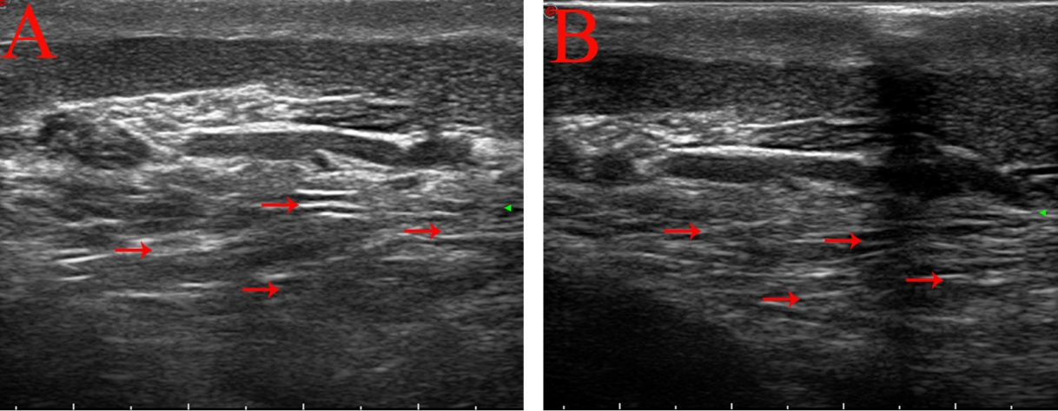
Figure S1. (A, B) Mesh change of epididymis ducts as determined by ultrasound. Relevantly mesh change of epididymis duct are indicated by arrows
Figure S2. (A) Globozoospermia patients presented spermatozoa with round-headed spermatozoa that lacked an acrosome. (B) The normal spermatozoa with the intact acrosome. Relevantly round-headed spermatozoa are indicated by arrows
Table S1. Clinical characteristics of patients included in the study.
 | A（n = 9） | B（n = 16） | p value
Age(y) | 29 ± 3.48 | 31 ± 5.25 | 0.07
FSH(IU/L) | 5.2 ± 1.25 | 4.7 ± 3.82 | > 0.05
LH(IU/L) | 5.0 ± 1.59 | 5.3 ± 2.15 | 0.075
T(nmol/l) | 10 ± 3.15 | 9.5 ± 4.21 | 0.437
E₂(pmol/l) | 72 ± 0.19 | 70 ± 1.35 | 0.07
Average testicular volume (mL) | 12 ± 1.34 | 15 ± 3.19 | > 0.05
Note: Data were analyzed using one-way analysis of variance and a two-sided Student’s t-test. Data were presented as the mean ± SD. Testicular volumes were evaluated using ultrasound examination A: Globozoospermia; B: Obstructive azoospermia.

