Supplementary Materials for Adsorption of Extracellular Polymeric Substances Derived from S. cerevisiae to Ceria Nanoparticles and the Effects on Their Colloidal Stability
Shota Masaki, Yuriko Nakano, Kenta Ichiyoshi, Keisuke Kawamoto, Ayaka Takeda, Toshihiko Ohnuki, Michael F. Hochella, Jr. and Satoshi Utsunomiya
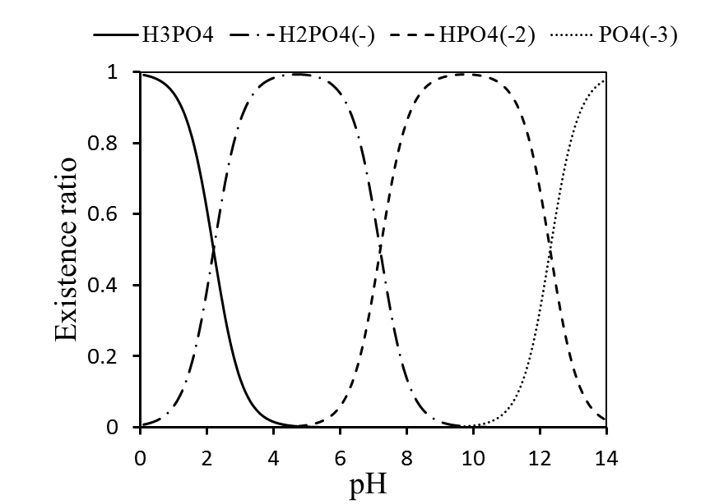
H₃PO₄
H₂PO₄⁻
HPO₄²⁻
PO₄³⁻

Fig. S1. Fraction of phosphate species in solution as a function of pH.

Interpretation of particle-particle interaction by DLVO theory
The DLVO theory is a useful tool to explain the agglomeration behaviors of particles under various aqueous conditions (Derjaguin and Lamdau, 1941; Verwey and Overbeek, 1948). Here, the agglomeration behaviors of CeNPs are considered based on the DLVO theory. The DLVO total interaction energy (V_{tot}) is determined by the sum of van der Waals attractive energy (V_{vdw}) and electric double layer repulsive energy (V_{ele}) that exist between particles as they undergo Brownian motion (Elimelech et al., 1995).
$$V_{tot}=V_{vdw}+V_{ele}$$ | (S1)
In the case of the particle-particle interaction, the van der Waals attractive energy and electric double layer repulsive energy are expressed as the follow:
$$V_{vdw}=-\frac{A}{6D}\left(\frac{R_{1}R_{2}}{R_{1}+R_{2}}\right)$$ | (S2)
$$V_{ele}=\left(\frac{R_{1}R_{2}}{R_{1}+R_{2}}\right)Zexp\left[-κD\right]$$ | (S3)
$$Z=64πε_{0}ε{\left(\frac{kT}{e}\right)}^{2}\tanh^{2}\left(\frac{zeψ_{0}}{4kT}\right)$$ | (S4)
$$κ^{-1}=0.304 × {{10}^{-9}}/{\sqrt{M}} \left(in case of mono electrolyte solution\right)$$ | (S5)

A (J): Hamaker constant (A = 5.57 × 10⁻²⁰ in case of CeO₂ (Karimian and Babaluo, 2007))
R₁, R₂ (m): Radious of two interacting particles
D (m): Distance between surfaces of two interacting particles
$κ$(m⁻¹): Reciprocal of the thickness of the double layer
ε₀ (C²J⁻¹m⁻¹): Electric permittivity in vacuum (ε₀= 8.854 × 10⁻¹²)
ε: Specific inductive capacity (ε = 78.4, in water, T = 298 K)
k: Boltzmann constant (k = 1.381 × 10⁻²³)
T (K): Temperature (T = 298 K)
e (C): Quantum of electricity (e = 1.602 × 10⁻¹⁹)
Ψ₀ (mV): Surface potential
M (mol L⁻¹): Electrolyte concentration

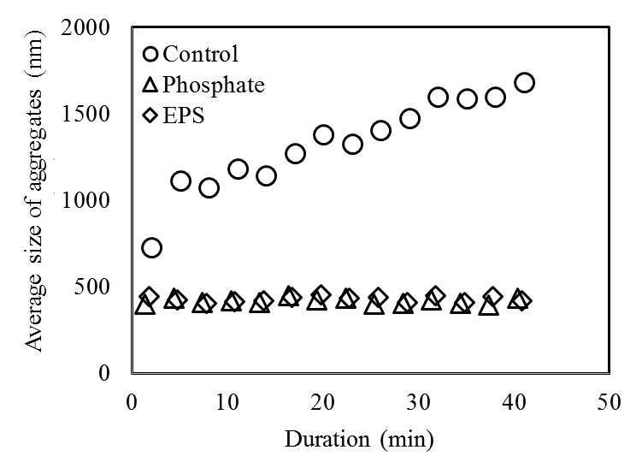
Fig. S2. Time-dependent variation in the average size of CeNP aggregates at 100 mg L-1 CeNP concentration monitored by dynamic light scattering (DLS): (○) control solution, (△) inorganic orthophosphate solution, and (◇) EPS solution.
Figure S3 shows the the V_{tot} plot calculated based on the equations (S1-4) in the solution with the electrolyte concentration of 0.001 mol L⁻¹.
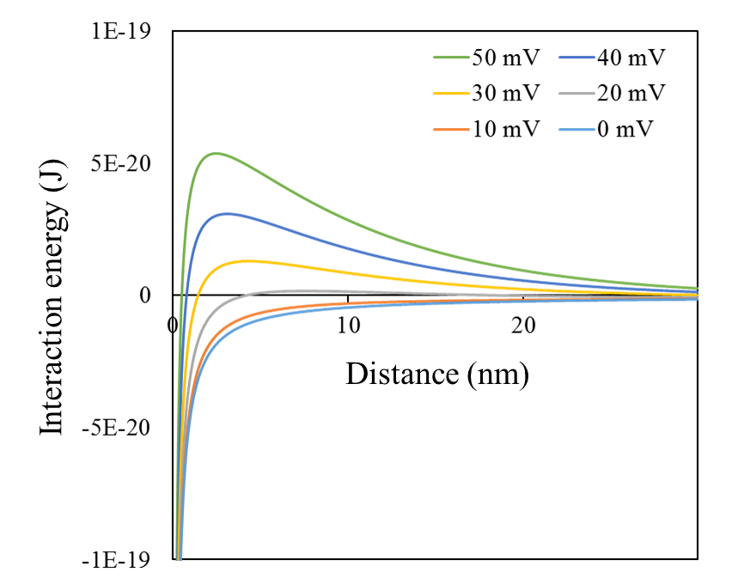
Fig. S3. Net energy of interaction for particles with various surface potentials at the constant ionic strength.

