Appendix A
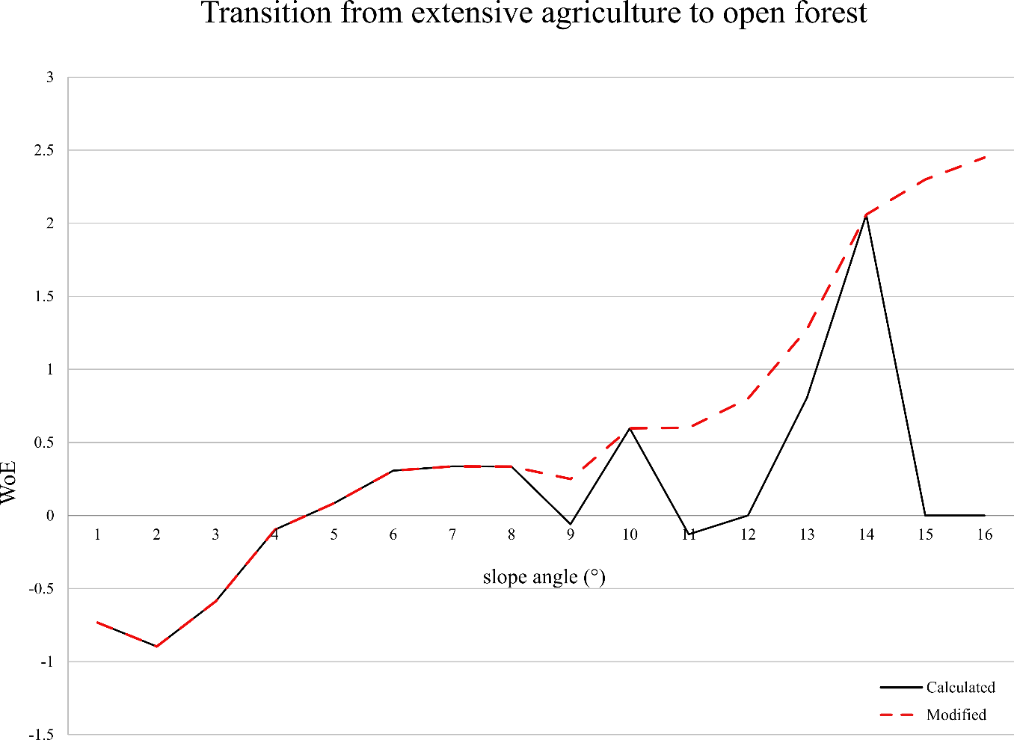
Figure S1: WoE for the different values of slope angles (SLOPE) in VS_R2, for the transition between extensive agriculture and open forest. The higher the WoE values, the greater the probability of the transition occurring, while low values of WoE indicate a lower probability. This plot shows an example of when the WoE needs to be edited to correct statistically insignificant WoE values.

Figure S2: WoE (y-axis) for the relationship between the mean annual precipitation in mm (x-axis) with the transition from shrubland to open forest, in VS_R1, VD_R2 and VS_R2.

Table 1 - Table 4 list, for each model, the transitions, and drivers used, as well as their influence over each transition displayed by means of a heatmap matrix. The drivers influence was obtained by summing their absolute values and the colour scales were defined for each transition. The drivers influence is represented in red to light blue colour scheme. Strong influence between the drivers and the transition is displayed in red, weak influence is displayed in light blue. Drivers with weak influence and excluded from the modelling are displayed in dark blue.
 | From | 1 |  |  | 2 |  |  |  | 3 |  |  | 4 |  |  |  |  | 5
Drivers | To | 2 | 4 | 5 | 1 | 4 | 5 | 8 | 4 | 5 | 8 | 2 | 3 | 5 | 8 | 9 | 2 | 4 | 6
DD to 1
DD to 2
DD to 3
DD to 4
DD to 5
DD to 6
DD to 8
DD to 9 |  |  |  |  |  |  |  |  |  |  |  |  |  |  |  |  |  |  |  |  | Not
ELEVATION |  |  |  |  |  |  |  |  |  |  |  |  |  |  |  |  |  |  |  |  | considered
SLOPE |  |  |  |  |  |  |  |  |  |  |  |  |  |  |  |  |  |  |  |  | Excluded
TOPO
TWI25 |  |  |  |  |  |  |  |  |  |  |  |  |  |  |  |  |  |  |  |  | Min (>0.5)
TRI
TEMP
PCP
SWB
MSRAD |  |  |  |  |  |  |  |  |  |  |  |  |  |  |  |  |  |  |  |  | Max
MMIND
GAMS
APTSOIL
LIMAGRIC
POP
DensityRoad
DistAA
DistHydro
DistPerturb
1: closed forest; 2: open forest; 3: permanent crops; 4: intensive agriculture; 5: extensive agriculture; 6: shrubland; 8: urban; 9: industry
Table S1: Drivers influence over each transition for VD_R1. In grey, variables that were not considered; in dark blue excluded variables with $\sum{\left|WoE\right|≤0.5};$ from light blue to red, the contribution of each driver to the respective land use transition.

 | From | 1 | 2 |  |  | 3 |  | 4 |  |  |  | 5 | 6
Drivers | To | 2 | 1 | 3 | 4 | 4 | 8 | 3 | 5 | 8 | 9 | 4 | 2
Dynamic Dist to 1
Dynamic Dist to 2
Dynamic Dist to 3
Dynamic Dist to 4
Dynamic Dist to 5
Dynamic Dist to 6
Dynamic Dist to 8
Dynamic Dist to 9 |  |  |  |  |  |  |  |  |  |  |  |  |  |  | Not
ELEVATION |  |  |  |  |  |  |  |  |  |  |  |  |  |  | considered
SLOPE |  |  |  |  |  |  |  |  |  |  |  |  |  |  | Excluded
TOPO
TWI25 |  |  |  |  |  |  |  |  |  |  |  |  |  |  | Min (>0.5)
TRI
TEMP
PCP
SWB
MSRAD |  |  |  |  |  |  |  |  |  |  |  |  |  |  | Max
MMIND
GAMS
APTSOIL
LIMAGRIM
POP
DensityRoad
DistAA
DistHydro
DistPerturb
1: closed forest; 2: open forest; 3: permanent crops; 4: intensive agriculture; 5: extensive agriculture; 6: shrubland; 8: urban; 9: industry
Table S2: Drivers influence over each transition for VS_R1. In grey, variables that were not considered; in dark blue excluded variables with $\sum{\left|WoE\right|≤0.5}$; from light blue to red, the contribution of each driver to the respective land use transition.

 | From FromTo | 1 |  | 2 |  | 4 |  |  | 5 |  |  |  | 6 |  |  | 11
Drivers | To To | 2 | 5 | 1 | 5 | 2 | 5 | 8 | 1 | 2 | 4 | 6 | 1 | 2 | 5 | 13
Dynamic Dist to 1
Dynamic Dist to 2
Dynamic Dist to 3
Dynamic Dist to 4
Dynamic Dist to 5
Dynamic Dist to 6
Dynamic Dist to 8
Dynamic Dist to 9
Dynamic Dist to 13 |  |  |  |  |  |  |  |  |  |  |  |  |  |  |  |  |  | Not
ELEVATION |  |  |  |  |  |  |  |  |  |  |  |  |  |  |  |  |  | considered
SLOPE |  |  |  |  |  |  |  |  |  |  |  |  |  |  |  |  |  | Excluded
TOPO
TWI |  |  |  |  |  |  |  |  |  |  |  |  |  |  |  |  |  | Min (>0.5)
TRI
TEMP
PCP
SWB
MSRAD |  |  |  |  |  |  |  |  |  |  |  |  |  |  |  |  |  | Max
MMIND
GAMS
APTSOIL
LIMAGRIM
POP
DensityRoad
DistAA
DistHydro
1: closed forest; 2: open forest; 4: intensive agriculture; 5: extensive agriculture; 6: shrubland; 8: urban; 11: glaciers and permanent snow; 13: rocks and sand.
Table S3: Drivers influence over each transition for VD_R2. In grey, variables that were not considered; in dark blue excluded variables with $\sum{\left|WoE\right|≤0.5}$; from light blue to red, the contribution of each driver to the respective land use transition.

 | From | 1 |  | 2 |  |  |  | 4 |  |  |  |  | 5 |  |  |  | 6 |  | 11
Drivers | To | 2 | 5 | 1 | 4 | 5 | 8 | 1 | 2 | 5 | 6 | 8 | 2 | 4 | 6 | 8 | 1 | 2 | 13
Dynamic Dist to 1
Dynamic Dist to 2
Dynamic Dist to 3
Dynamic Dist to 4
Dynamic Dist to 5
Dynamic Dist to 6
Dynamic Dist to 8
Dynamic Dist to 9
Dynamic Dist to 13 |  |  |  |  |  |  |  |  |  |  |  |  |  |  |  |  |  |  |  |  | Not
ELEVATION |  |  |  |  |  |  |  |  |  |  |  |  |  |  |  |  |  |  |  |  | considered
SLOPE |  |  |  |  |  |  |  |  |  |  |  |  |  |  |  |  |  |  |  |  | Excluded
TOPO
TWI |  |  |  |  |  |  |  |  |  |  |  |  |  |  |  |  |  |  |  |  | Min (>0.5)
TRI
TEMP
PCP
SWB
MSRAD |  |  |  |  |  |  |  |  |  |  |  |  |  |  |  |  |  |  |  |  | Max
MMIND
GAMS
APTSOIL
LIMAGRIM
POP
DensityRoad
DistAA
DistHydro
1: closed forest; 2: open forest; 4: intensive agriculture; 5: extensive agriculture; 6: shrubland; 8: urban; 11: glaciers and permanent snow; 13: rocks and sand.
Table S4: Drivers influence over each transition for VS_R2. In grey, variables that were not considered; in dark blue excluded variables with $\sum{\left|WoE\right|≤0.5};$ from light blue to red, the contribution of each driver to the respective land use transition.

