Activated carbons from fast pyrolysis biochar as novel catalysts for the post-treatment of pyrolysis vapors, studied by analytical pyrolysis

Taina Ohra-aho^{1,}*, Christian Lindfors¹, Juha Lehtonen¹, Tarja Tamminen¹ and Virpi Siipola¹
¹ VTT Technical Research Centre of Finland Ltd, P.O.Box 1000, FI-02044 VTT, Espoo, Finland; christian.lindfors@vtt.fi (C.L.); juha.lehtonen@vtt.fi (J.L.); tarja.tamminen@vtt.fi (T.T.); virpi.siipola@vtt.fi (V.S.)
* Correspondence: taina.ohra-aho@vtt.fi; Tel.: +358 40 5709 322 (T.O.)

Supporting material

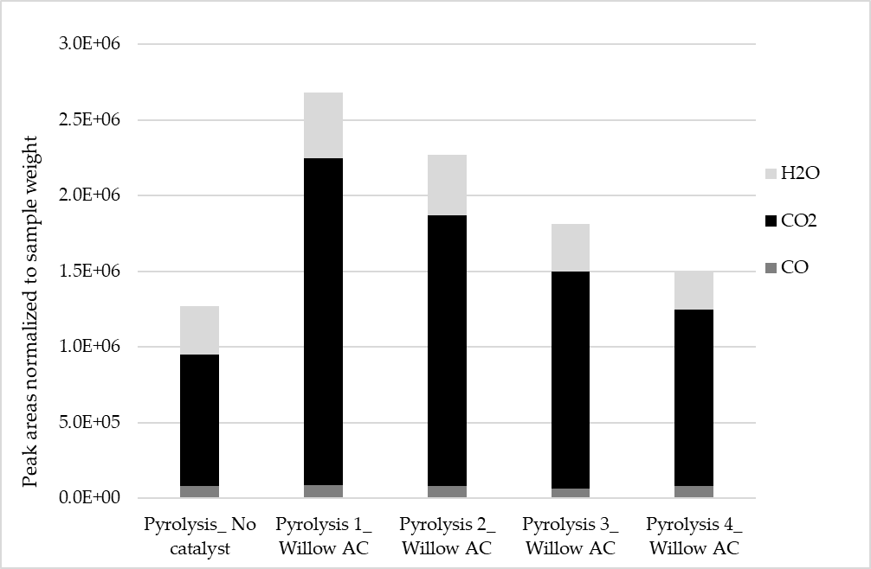
Figure S1. Gas and water release in thermal pyrolysis of pine (pyrolysis_No catalyst) and in post-treatment of pine pyrolysis vapours using four times the same original willow activated carbon (AC) as catalyst. Compounds analysed by GC/MSD.

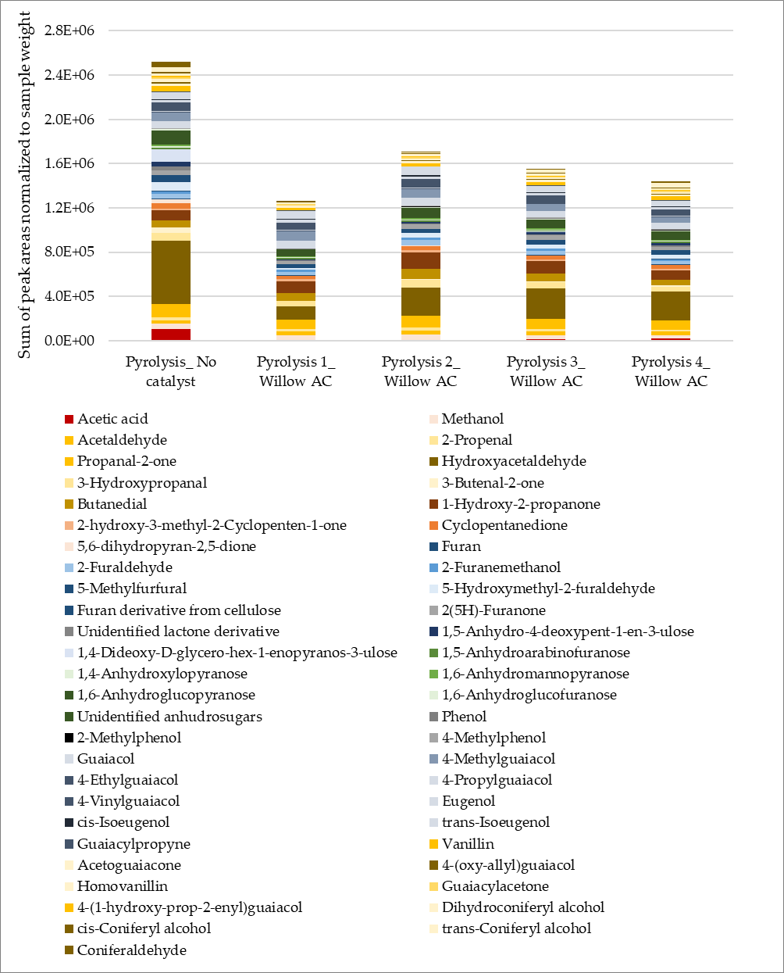
Figure S2. Polysaccharide and lignin pyrolysis derivatives released in thermal pyrolysis pine and in post-treatment of pine pyrolysis vapours using four times the same original willow activated carbon (AC) as catalyst. Compounds analysed by GC-FID.

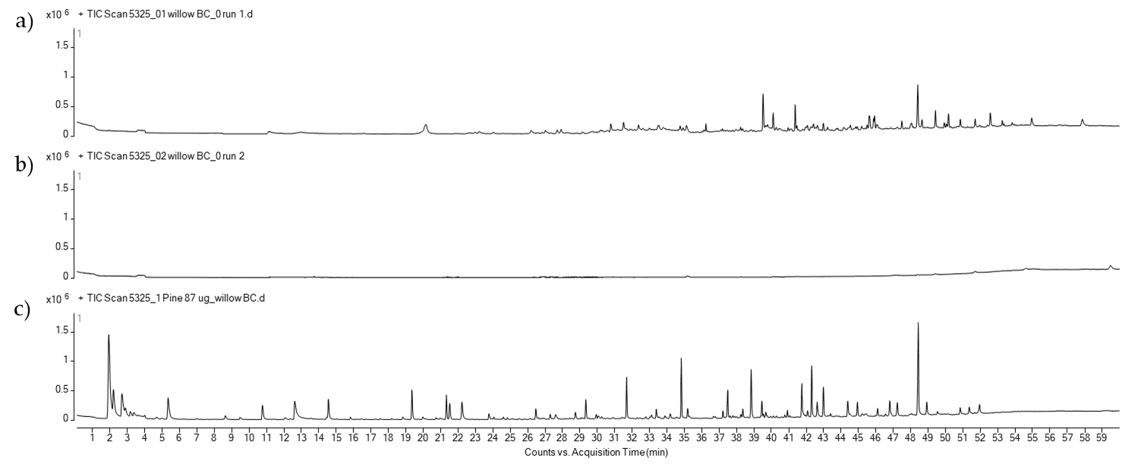
Figure S3. Total ion chromatograms of two pyrolysis runs with willow BC without biomass a) pretreatment 1 and b) pretreatment 2 and c) post-treatment of pine pyrolysis vapours using pretreated willow BC as catalyst.

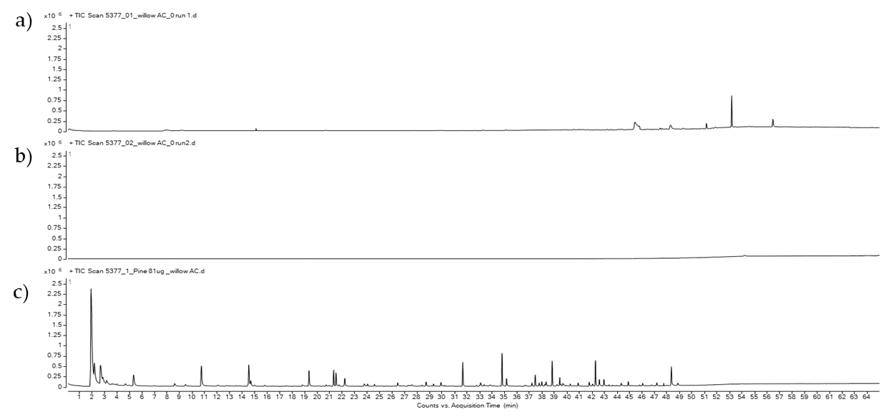
Figure S4. Total ion chromatograms of two pyrolysis runs with willow AC without biomass a) pretreatment 1 and b) pretreatment 2 and c) post-treatment of pine pyrolysis vapours using pretreated willow AC as catalyst.

